Lab 1: About Unity Game Engine

Harshaditya Sharma

22BAI1054

1. Download Unity Hub:
2. Go to the Unity website and download Unity Hub.
3. Open Unity Hub
4. GO To the installs Tab

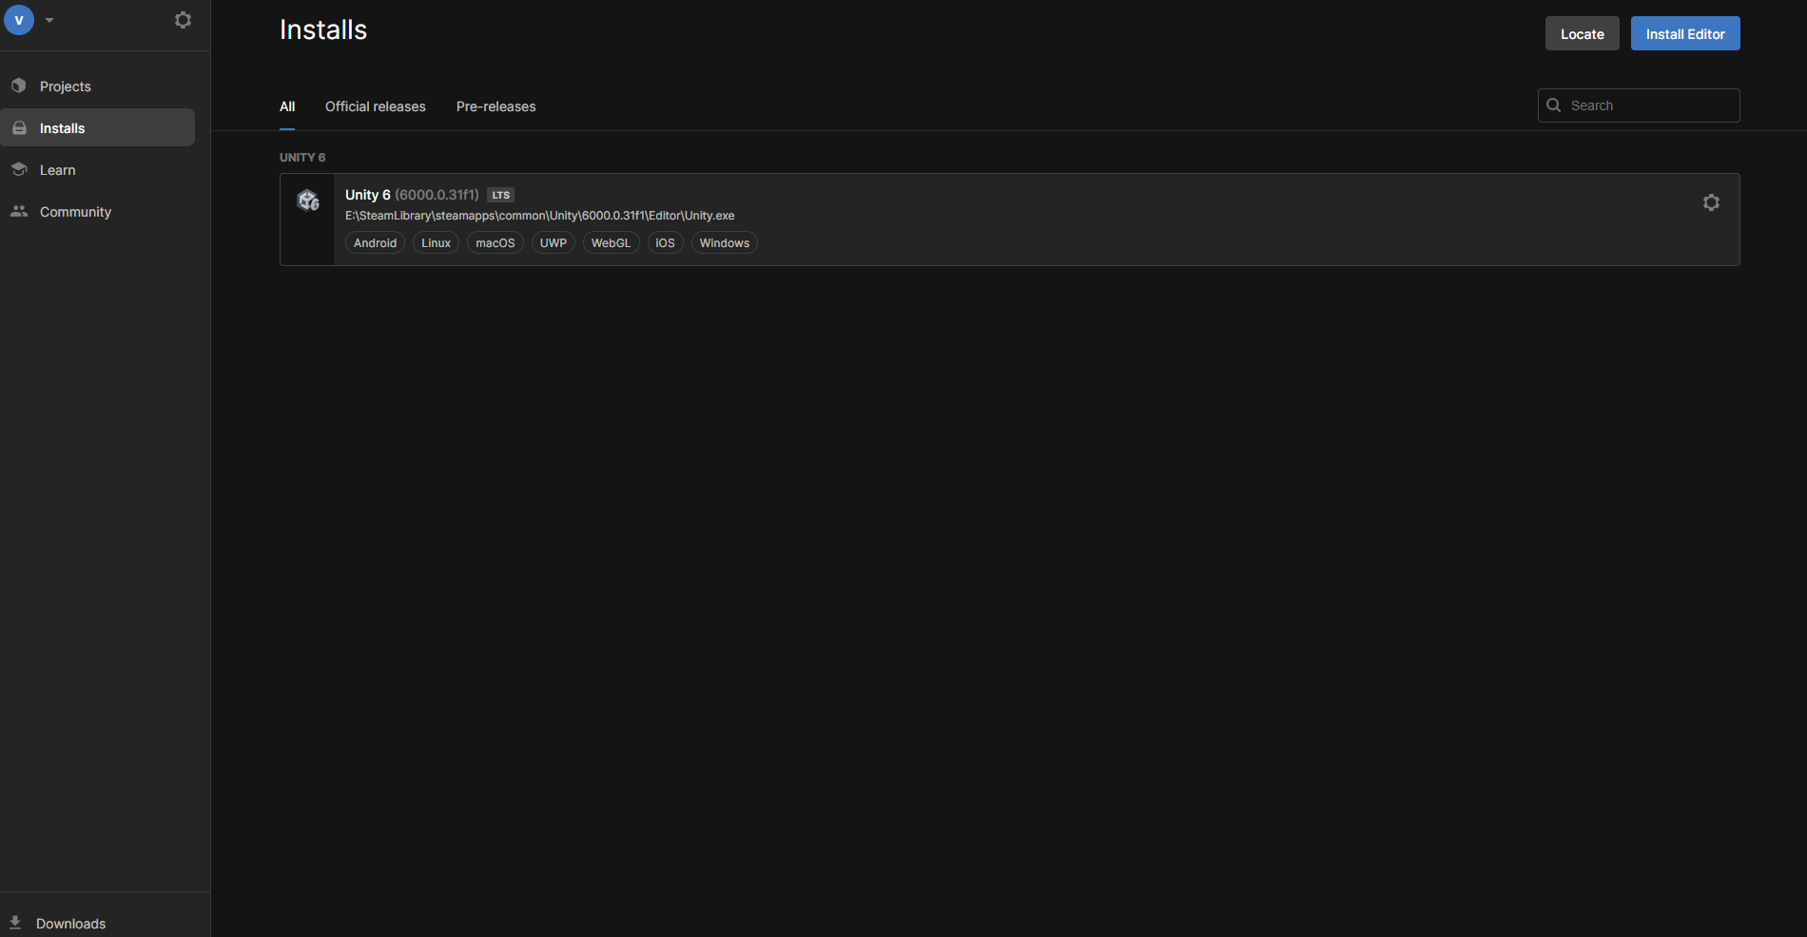

1. Click on **Install Editor** and select the version of Unity you want to install.

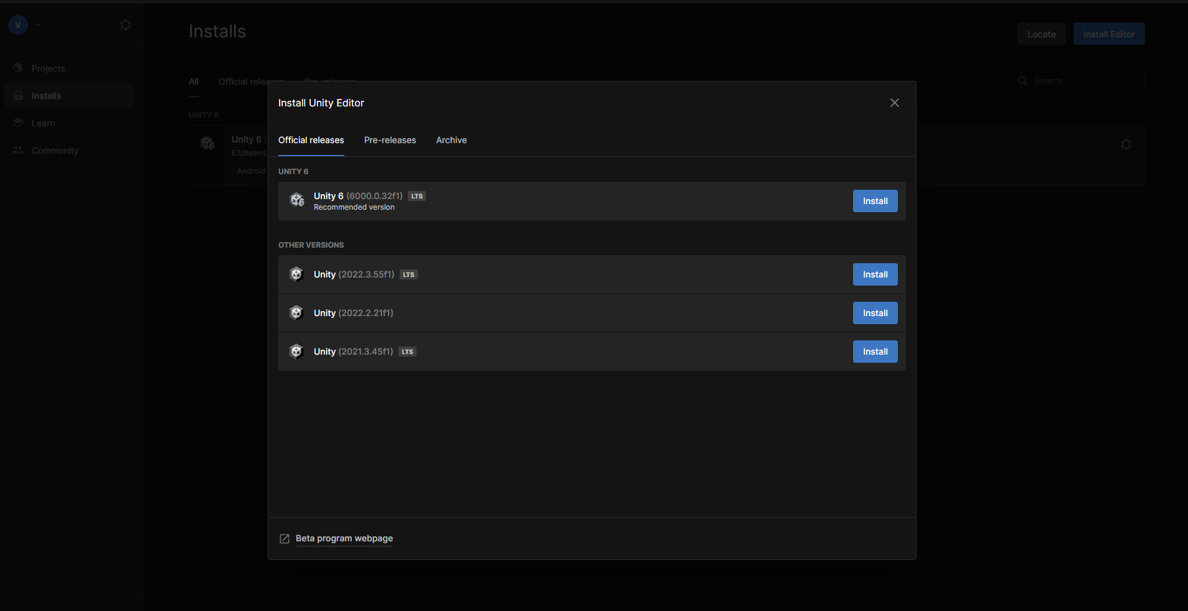

1. Choose additional components like Android Build Support if needed, and complete the installation.

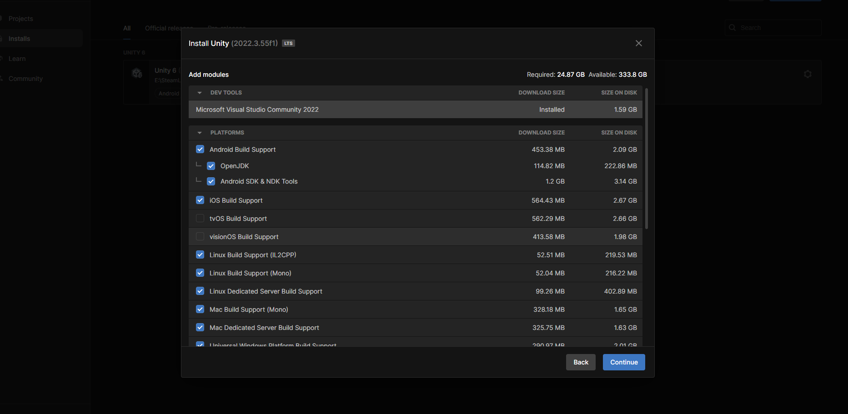

1. In the Unity Hub Projects tab, select New project.
2. Set the Editor version to 2022.2 and select the 3D Core template.
3. Name your project and save it somewhere safe on your computer.

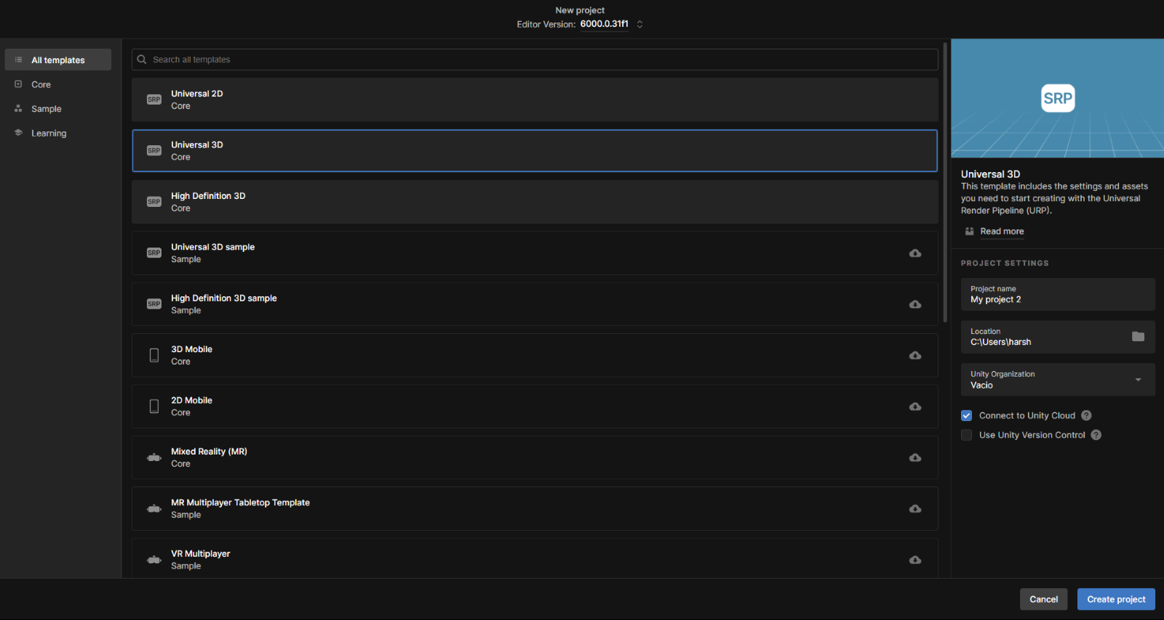

1. Select Create project and let Unity compile and open the project.

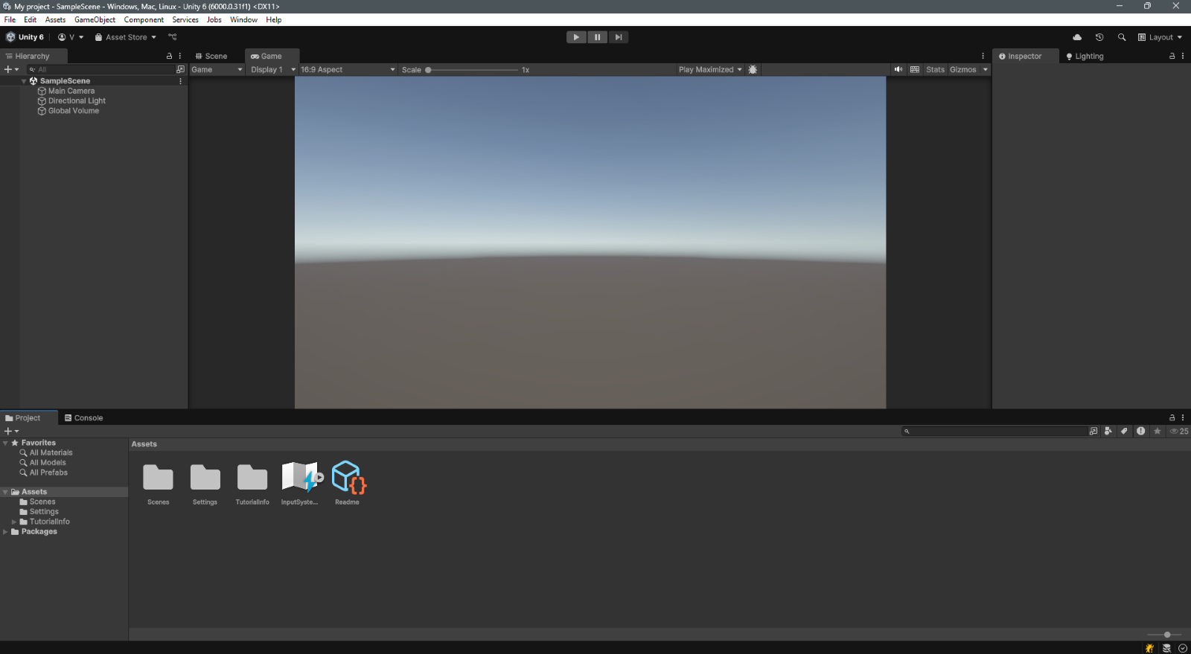

1. Working with 3D Models in Unity. Adding Built-In 3D Shapes.

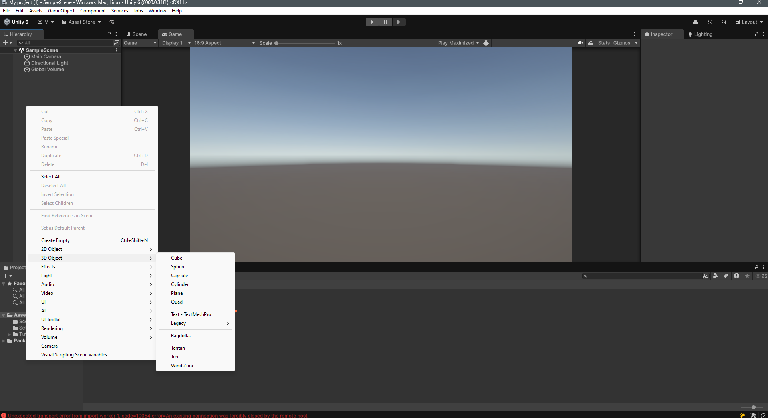

1. Shading, Lighting, and Shadows

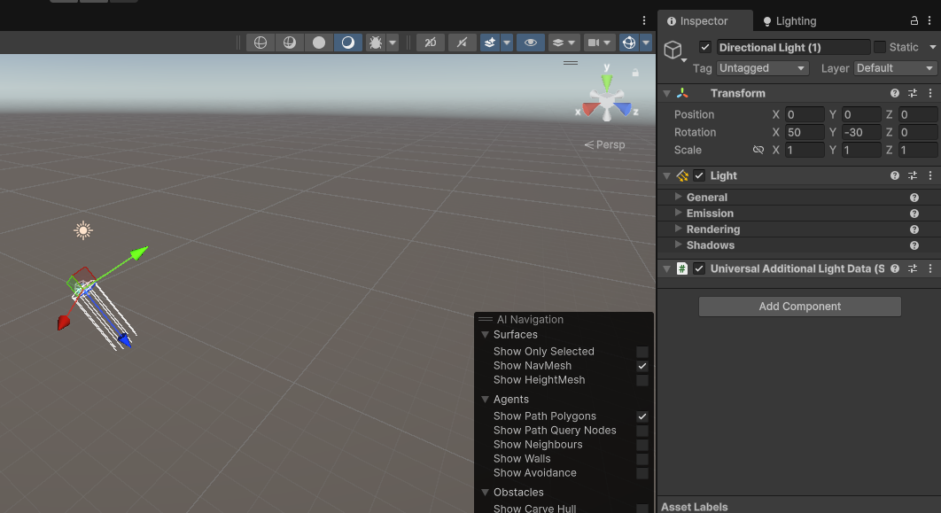

1. Model a Brick. Duplicate the Brick. Position the Wall

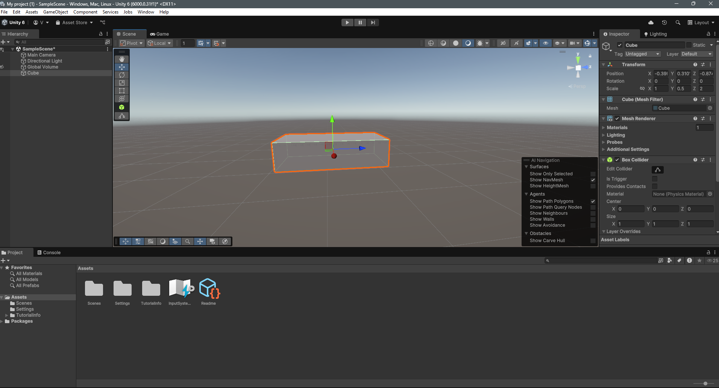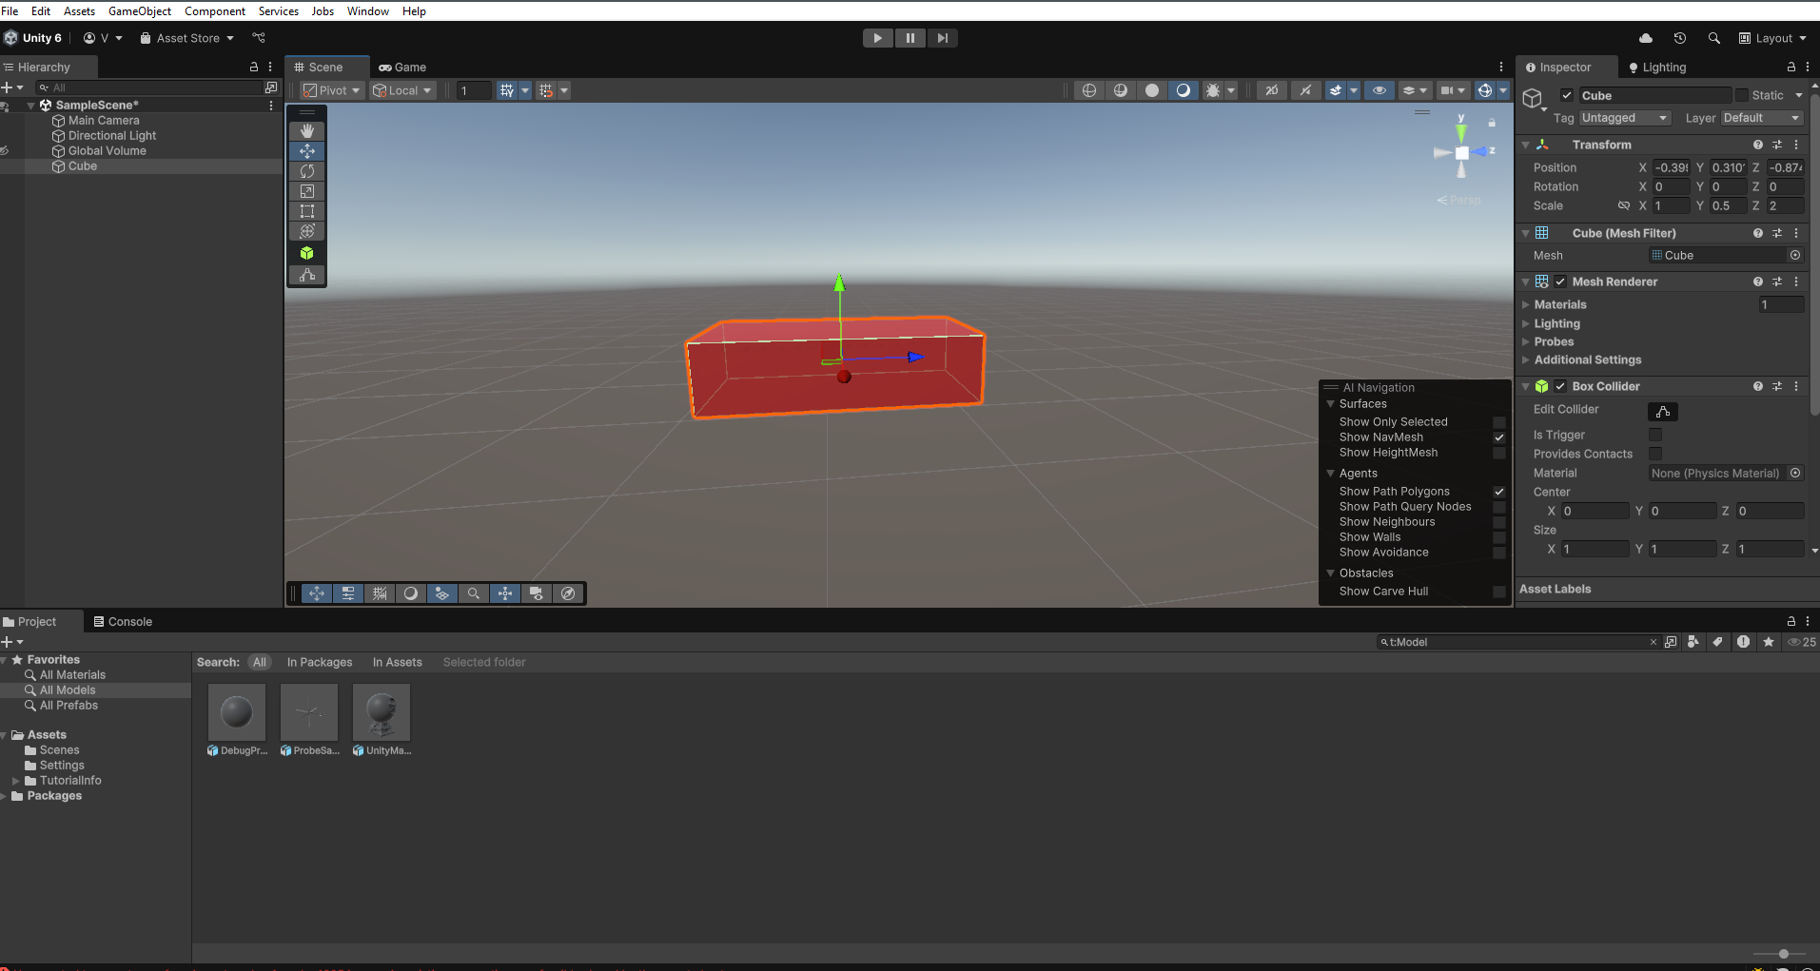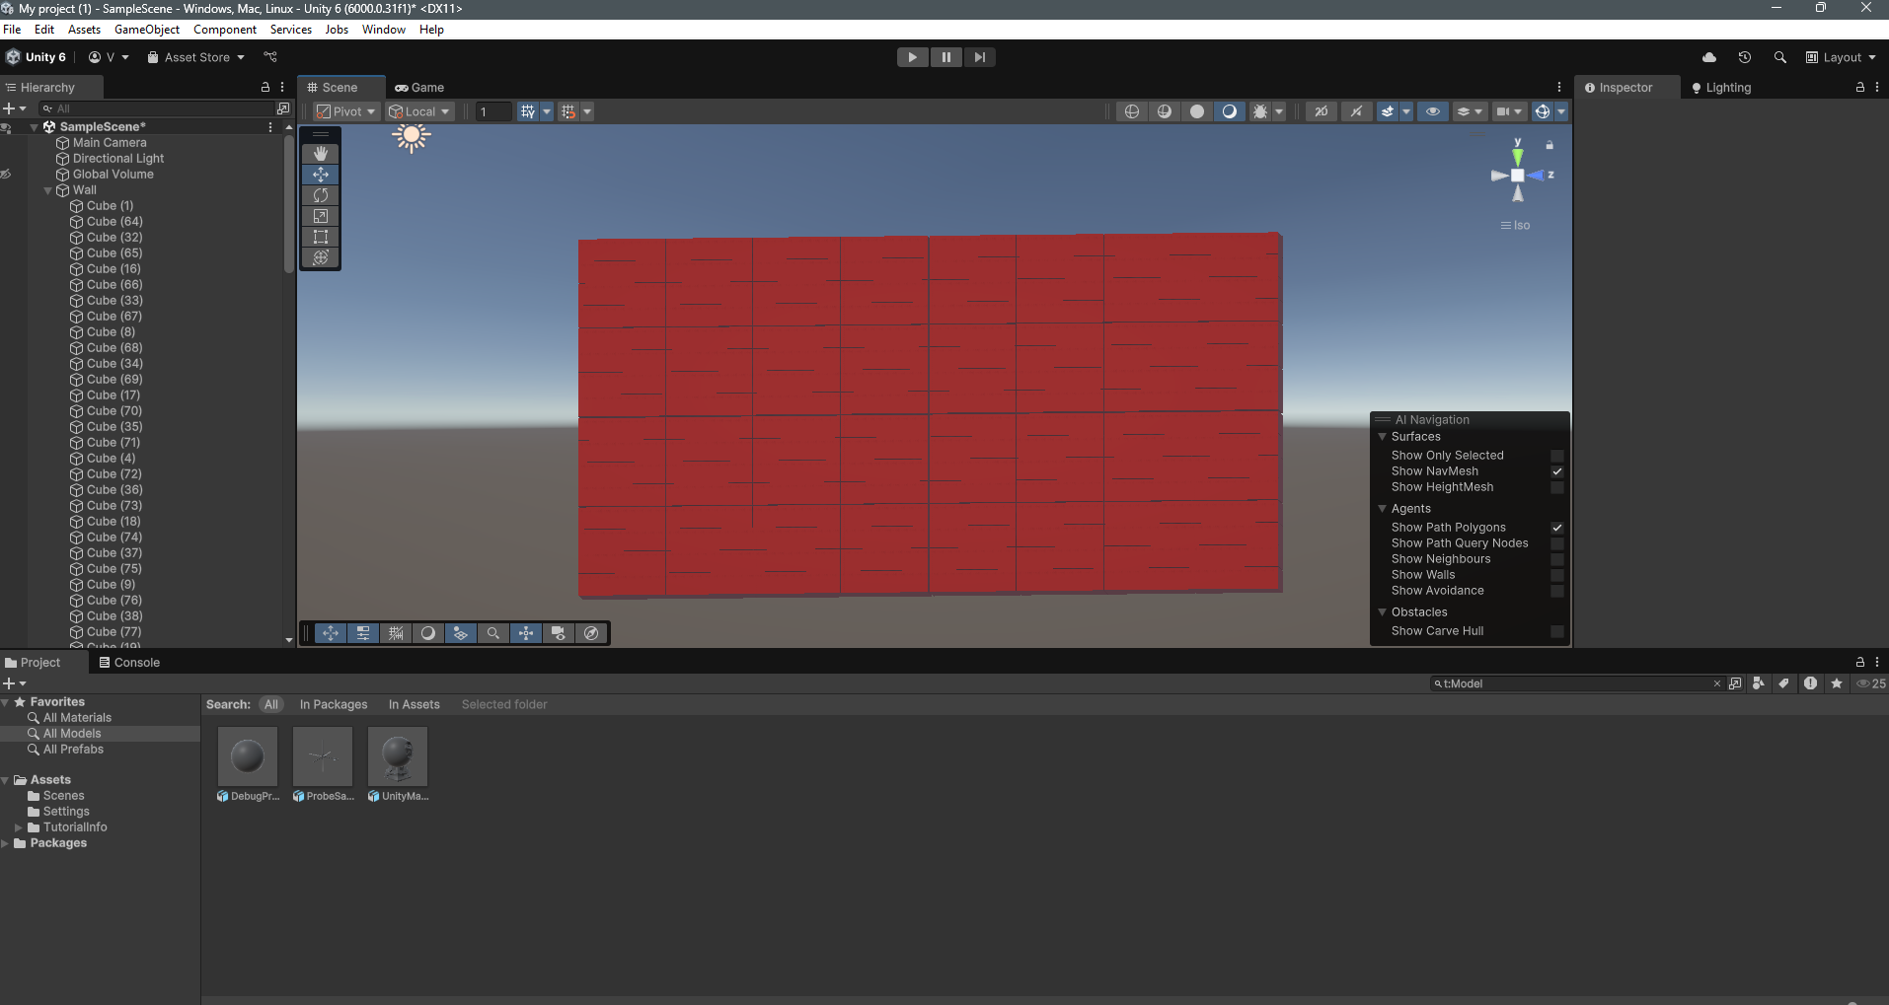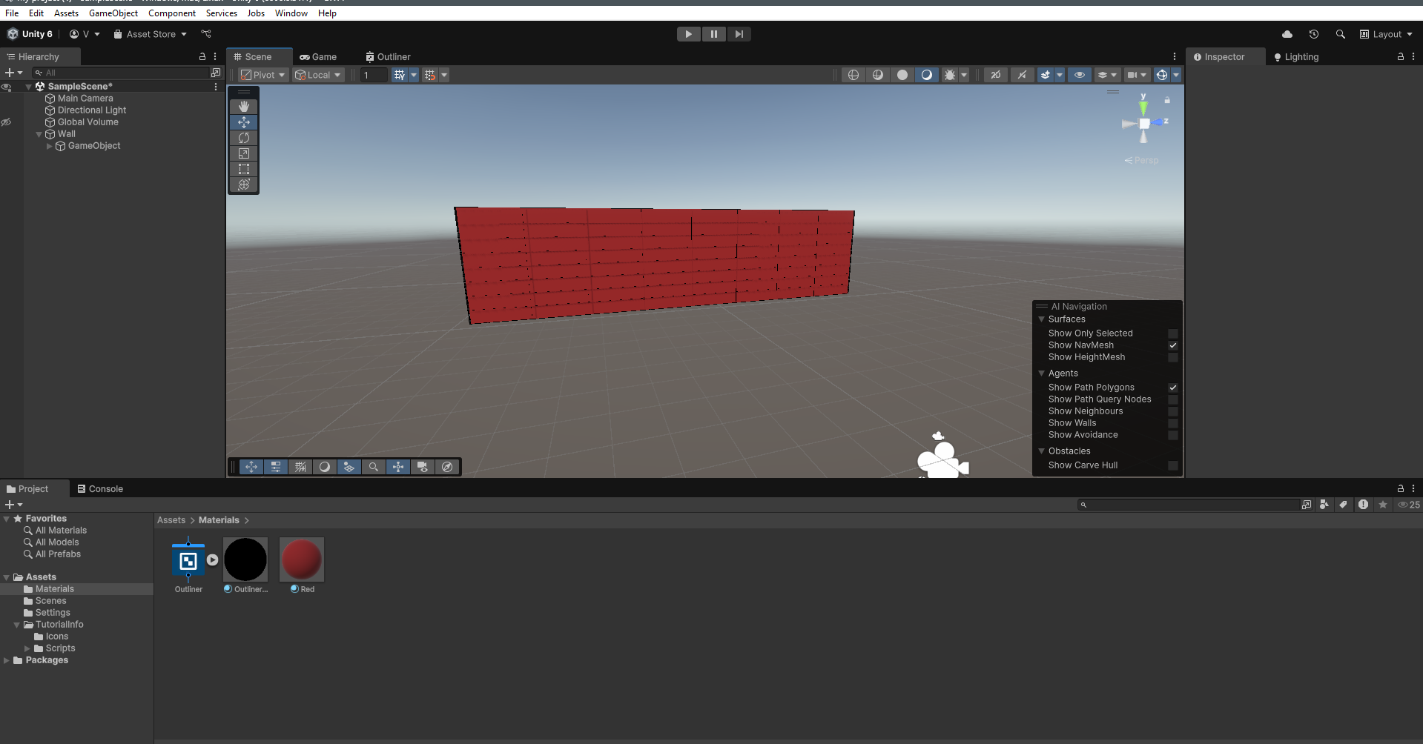

1. Creating a Grassy Ground. Add a Plane. Add a Grass Texture to it. Make The plane Large and you have a grassy land with a brick wall

